**ASSIGNMENT**

**Name- Suryakant Thakur**

**Roll No- 57**

**Dept. - IT**

**Date- 16-08-2020**

Ans 1.) In first we create the DEPT Table because It’s the Parent table of the EMP Table. In DEPT Table we use constraint PK_DEPT PRIMARY KEY(DEPTNO). In the Emp Table has a foreign key reference to the DEPT table.

**Creating DEPT Table**

**Command**

CREATE TABLE DEPT(

DEPTNO NUMBER(2),

DNAME VARCHAR2(14),

LOC VARCHAR2(13),

CONSTARINT PK_DEPT PRIMARY KEY (DEPTNO) );

**Creating EMP Table**

**Command**

**CREATE TABLE EMP(**

EMPNO NUMBER(30),

ENAME VARCHAR2(255),

JOB CHAR(10),

MGR NUMBER(30),

HIREDATE DATE,

SAL NUMBER(30),

COMM NUMBER(30),

DEPTNO NUMBER(30),

);

ALTER TABLE EMP ADD PRIMARY KEY (EMPNO)

ALTER TABLE EMP ADD FOREIGN KEY(DEPTNO) REFERENCES DEPT(DEPTNO)

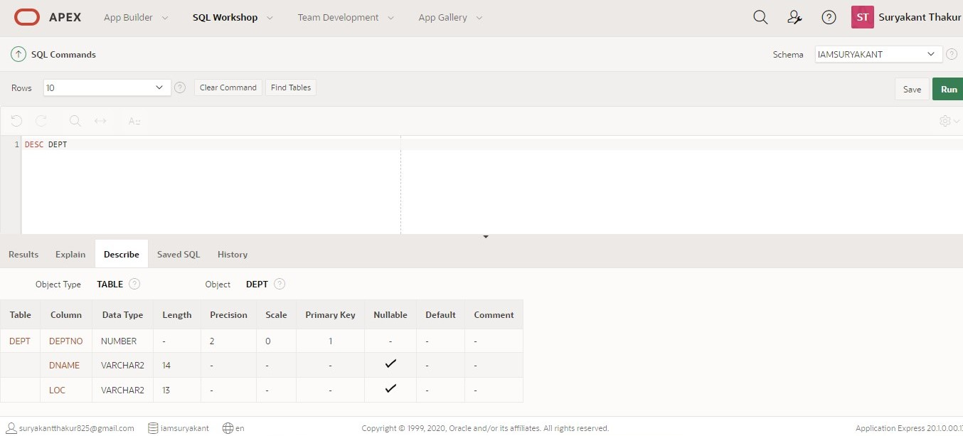

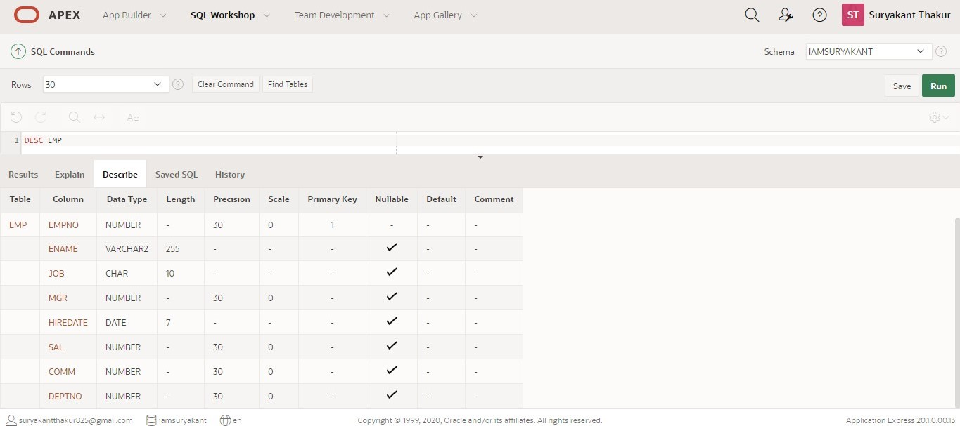

Ans 2.) **Add new attribute phone to table emp**

**Command**

ALTER TABLE EMP ADD PHONE NUMBER(10);

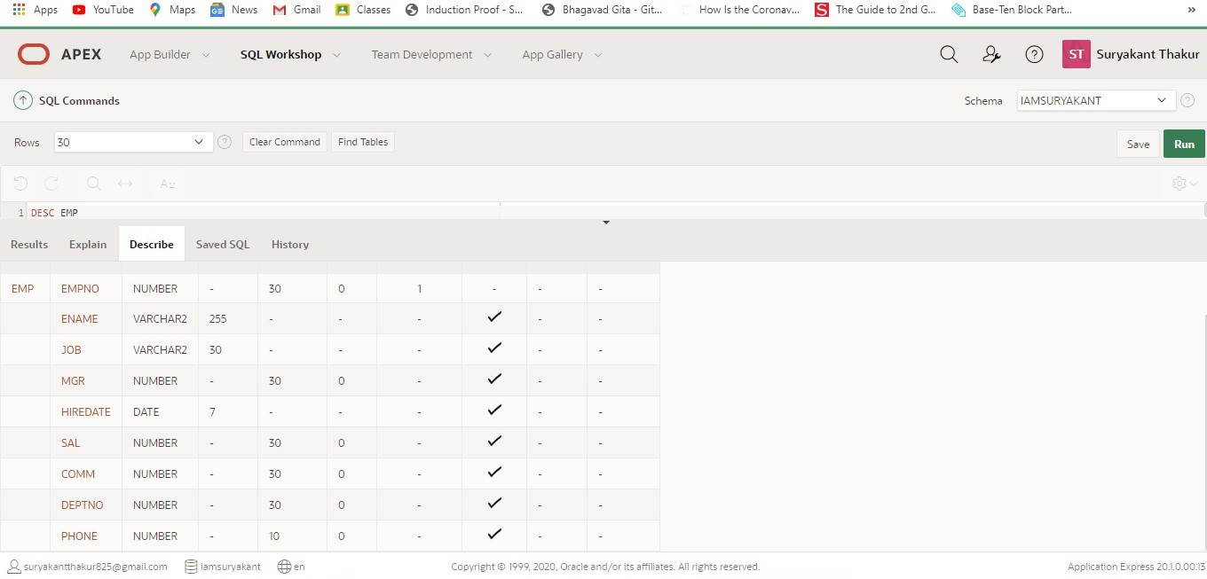

Ans 3). **Change data type of attribute JOB from CHAR to VARCHAR2**

**Command**

ALTER TABLE EMP MODIFY JOB VARCHAR2(30);

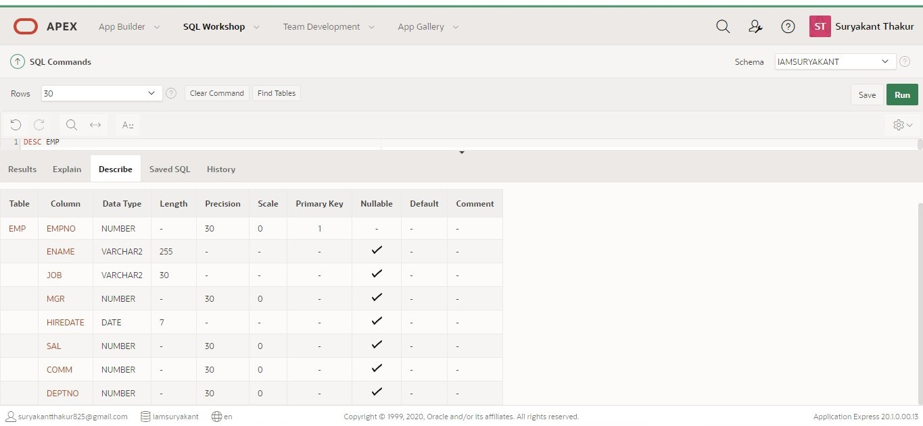

Ans 4.) **Remove the attribute PHONE from EMP**

**Command**

ALTER TABLE EMP DROP COLUMN PHONE;

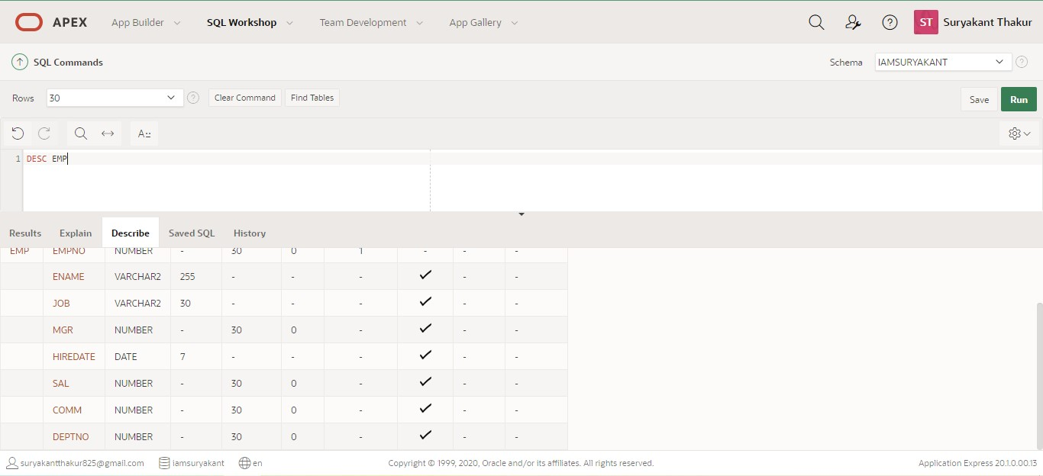

Ans 6.) Data for DEPT Table we Insert First. Then, we insert data for EMP Table.

**Inserting the data to the table**

**Command**

INSERT INTO EMP

VALUES (7499, 'ALLEN', 'SALESMAN', 7698,

TO_DATE('20-02-1981','DD-MM-YYYY'),

1600, 300, 30);

INSERT INTO EMP

VALUES (7521, 'WARD', 'SALESMAN', 7698,

TO_DATE('22-02-1981','DD-MM-YYYY'),

1250, 100, 30);

INSERT INTO EMP

VALUES (7566, 'JONES', 'MANAGER', 7839,

TO_DATE('02-04-1981','DD-MM-YYYY'),

2975, 300, 20);

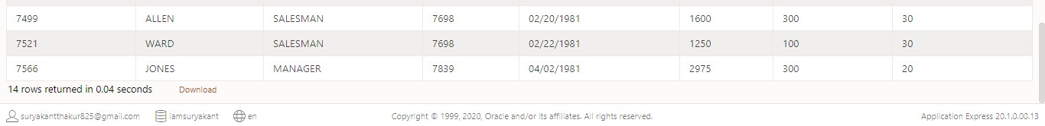

Ans 7.) i.) **Records for DEPT Table.**

**Query**

SELECT * FROM DEPT

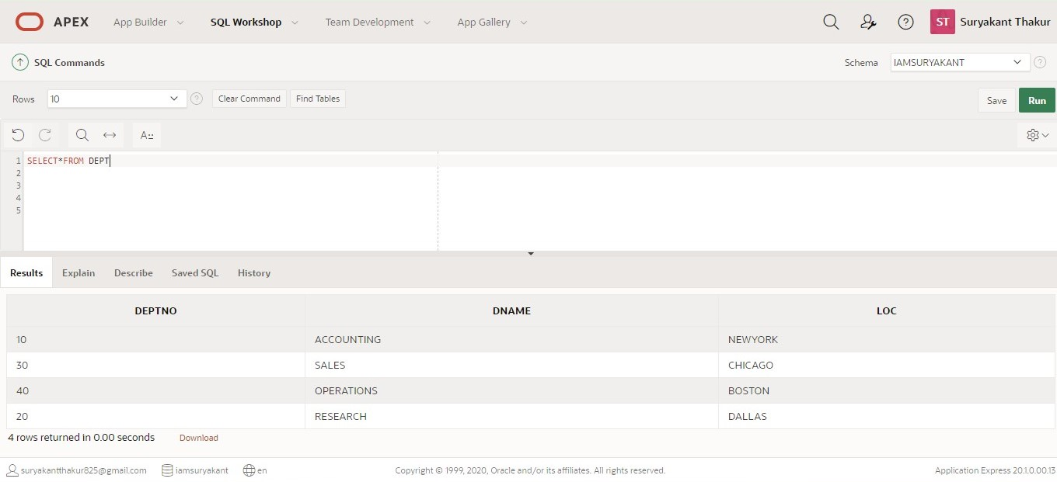

ii.) **Records for the EMP Table.**

**Query**

SELECT * FROM EMP

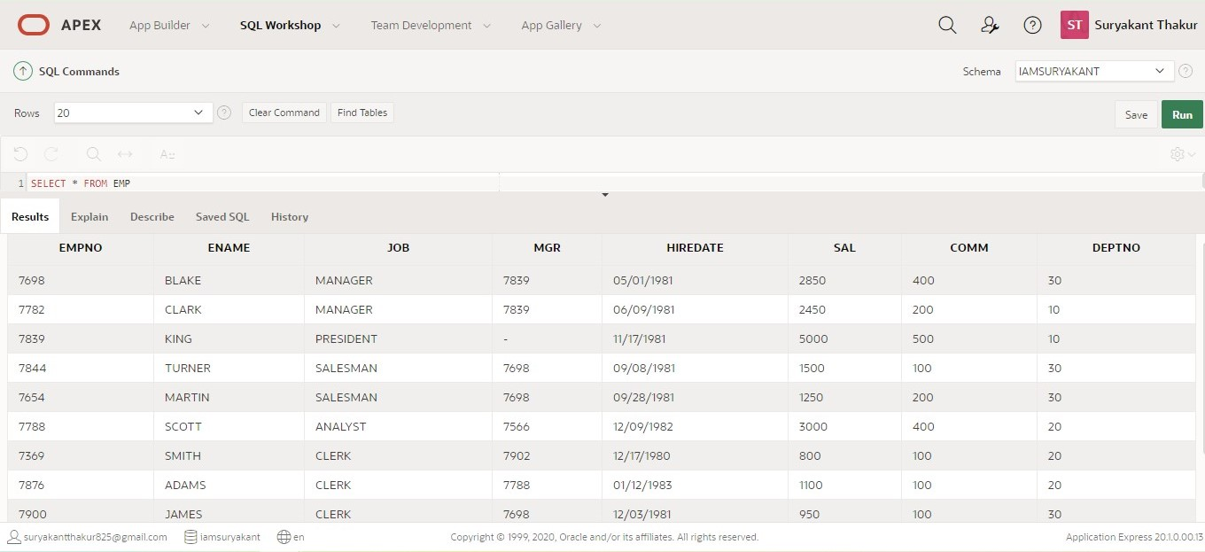

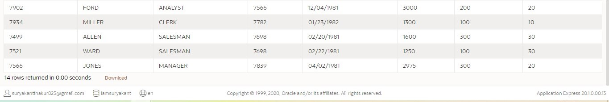

Ans 8.) **Display the details of all employees who get a salary more than 2000.**

**Query**

SELECT * FROM EMP WHERE SAL>2000;

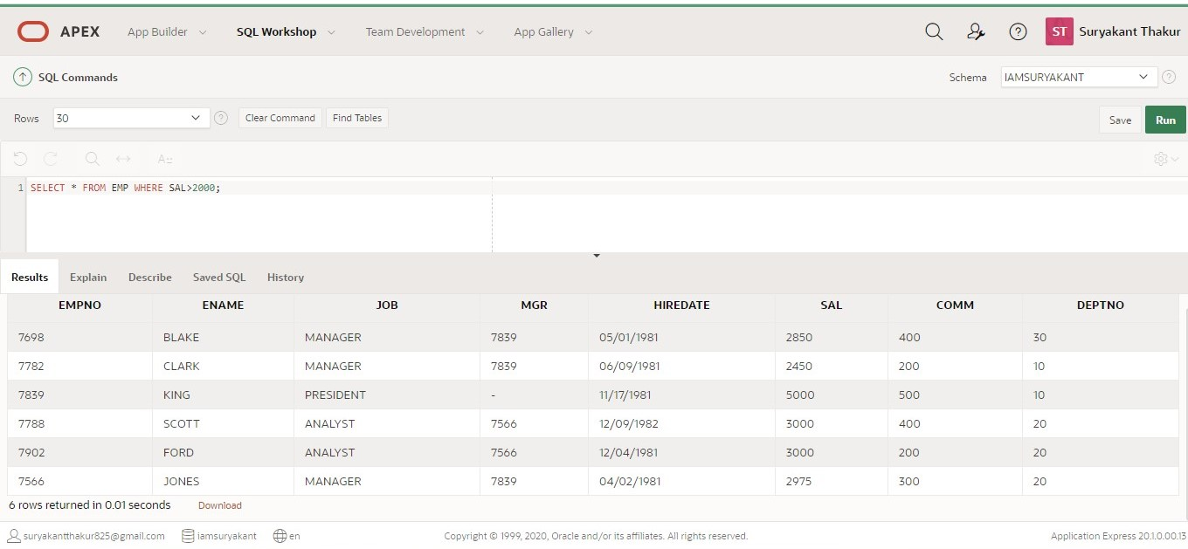

Ans 9.) **Display the names and jobs of all employees whose name begin with ‘S’.**

**Query**

SELECT ENAME, JOB FROM EMP WHERE ENAME LIKE ‘S%’ ;

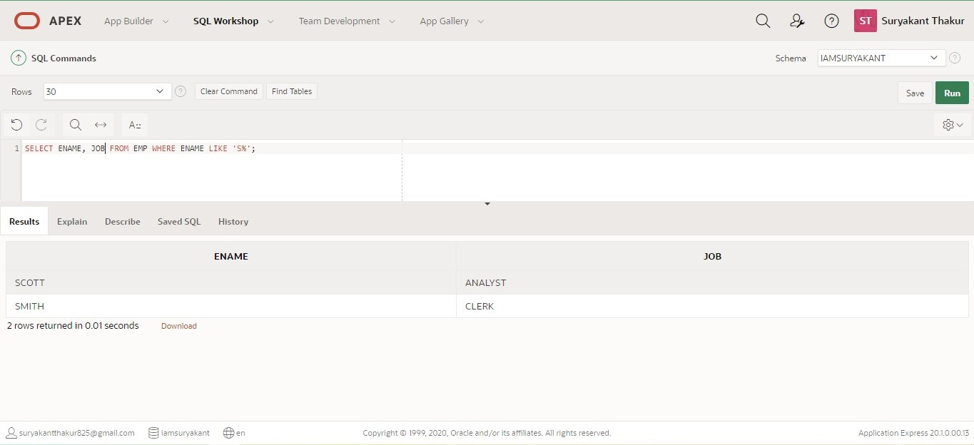

Ans 10.) **Display the employee numbers, names, jobs and salaries of all employees who work**

**as clerk but get a salary less than 1000.**

**Query**

SELECT EMPNO, ENAME, JOB, SAL FROM EMP WHERE JOB= ’CLERK’ AND SAL<1000;

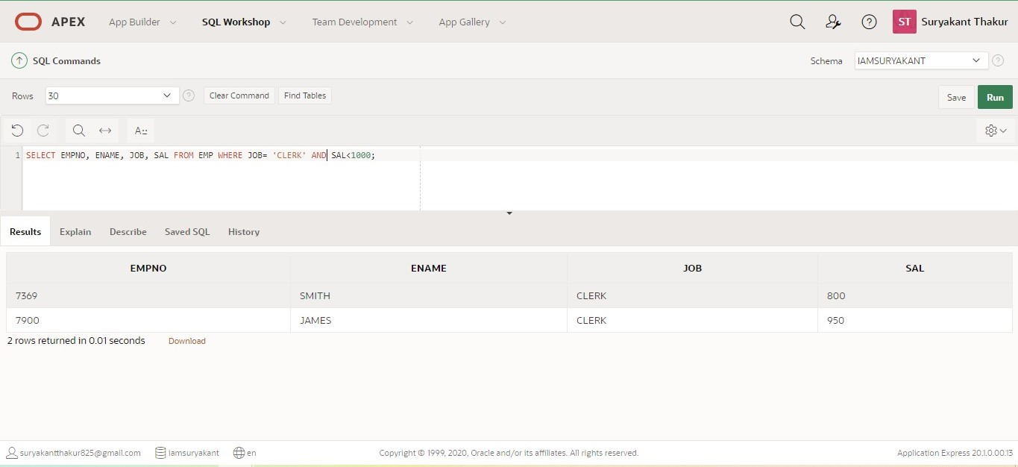

Ans 11.) **Find the sum of all salary paid.**

Query

SELECT SUM(SAL) FROM EMP;

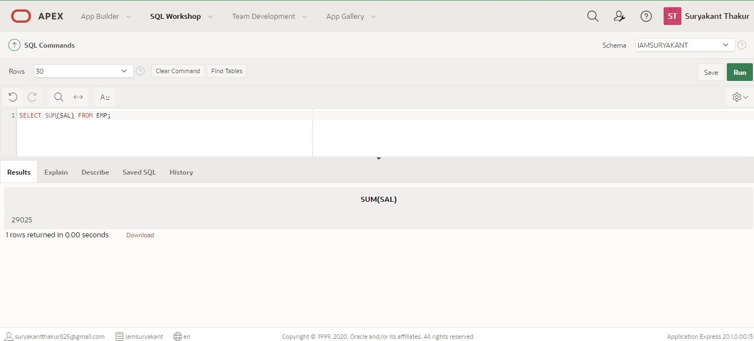

Ans. 12) **Find the largest commission being paid.**

**Query**

SELECT MAX(COMM) FROM EMP;

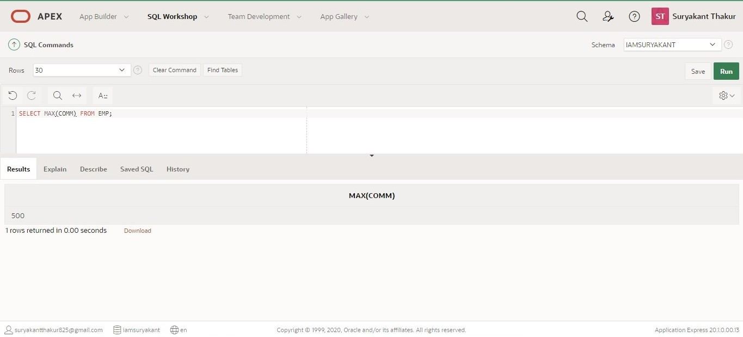

Ans. 13) **Display department wise average salary being paid.**

**Query**

SELECT DEPTNO, AVG(SAL) FROM EMP GROUPED BY DEPTNO;

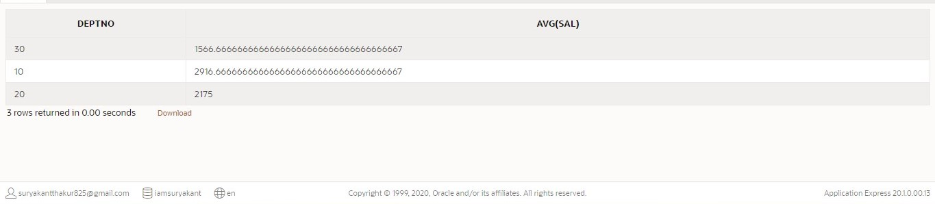

Ans 14.) **Display names, jobs and commissions of employees whose commissions are between**

**1000 and 2000 (both inclusive).**

**Query**

SELECT ENAME, JOB , COMM FROM EMP WHERE COMM BETWEEN 1000 AND 2000;

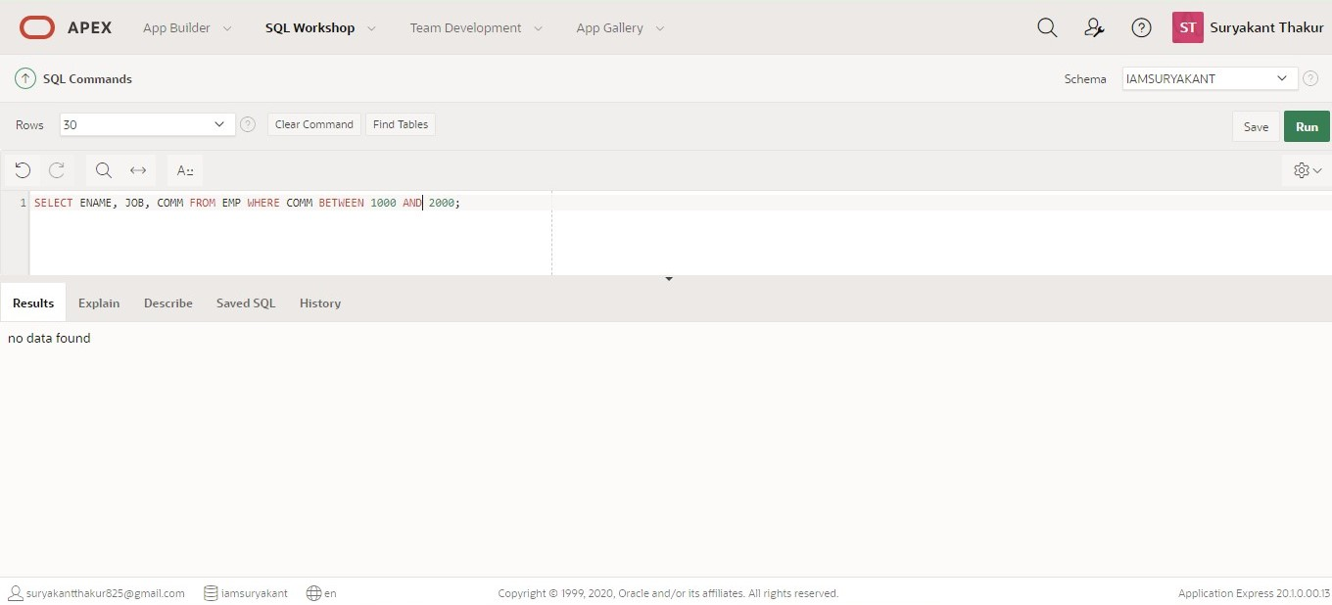

Ans 15.) **Display job wise maximum and minimum salaries being paid.**

**Query**

SELECT JOB, MAX(SAL) AS MAXIMUM, MIN(SAL) AS MINIMUM FROM EMP GROUP BY JOB;

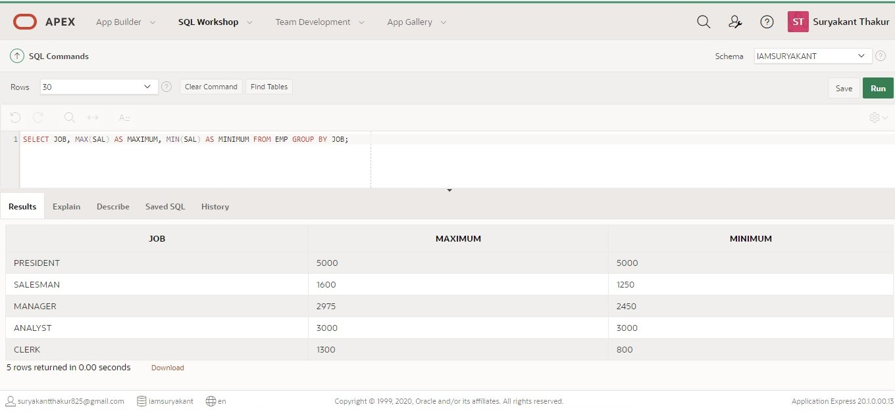

Ans 16.) **Display the details of the employees whose names begin with ‘B’ to ‘G’.**

**Query**

SELECT * FROM EMP WHERE ENAME >= ‘B’ OR ENAME < ‘H’;

